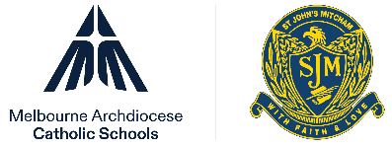


St John’s Mitcham

Governance Statement

MACS Governance Statement
St John’s Mitcham is a school which operates with the consent of the Catholic Archbishop of Melbourne and is operated and governed by Melbourne Archdiocese Catholic Schools Ltd (MACS).
MACS governs and operates Catholic schools in the Archdiocese to continue the mission of Catholic education to proclaim the Good News and equip our young people with the knowledge, skills, and hope to live meaningful lives and enrich the world around them.
Because the good work of educating the young is a co-responsible task led by every member of the Catholic school community, School Advisory Councils have been established to provide a crucial point of connection between the wider school community and school leaders. This governance model was designed to ease the administrative burden on our schools and parishes, allow parish priests to focus on the mission of education in the parish, enable greater collaboration between schools and ensure greater consistency in school policies and procedures.
More information about MACS is available at www.macs.vic.edu.au.

Policy information
Responsible director | Director, Governance and Strategy
Policy owner | Director, Governance and Strategy
Approving authority | MACS Board
Assigned board committee
Approval date | 25 March 2022
Risk Rating | Extreme
Date of next review
Publication | CEVN, school website

POLICY DATABASE INFORMATION
Assigned framework | Governance
Supporting documents
Superseded documents
New policy | New

